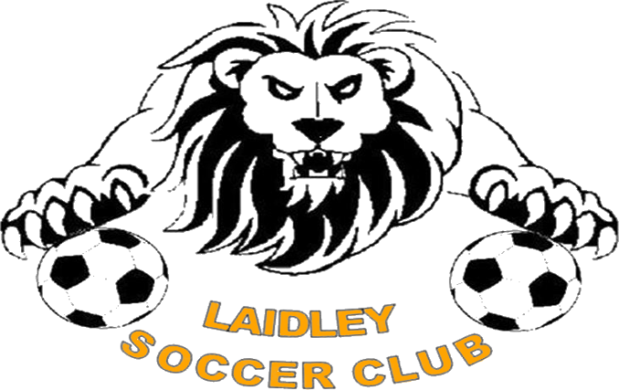

Good Sports Level 3

We are a Good Sports Level 3 accredited club.
Sporting clubs such as ours play a significant role in the community and have a responsibility to our members and their families. We have chosen to join over 6,500 clubs across Australia taking part in the Australian Drug Foundation’s Good Sports program. Through Good Sports we are committed to managing alcohol responsibly and ensuring smoke free areas, which we believe will help us to provide a healthy, safe and family friendly environment.

Through Good Sports we aim to:

- Eliminate risky drinking in the club through the promotion of a responsible approach to the sale and consumption of alcohol in the club
- Protect juniors and other young people from the misuse of alcohol in and around the club
- Provide a responsible smoke-free club environment, through designated smoking areas

At Level 3, we are committed to:
- Not selling or consuming alcohol without an appropriate liquor license
- Training our bar staff in Responsible Service of Alcohol (RSA)
- Ensuring smoke free areas are available
- Organising safe and responsible social events and finding alternate prizes/fundraiser, rather than alcohol
- Thinking ahead and ensuring players and members get home safely after functions
- Formalising and implementing our club’s alcohol management policy

Speak to our club committee about what being a Good Sports club is all about or visit www.goodsports.com.au or www.Facebook.com/GoodSportsClubs

