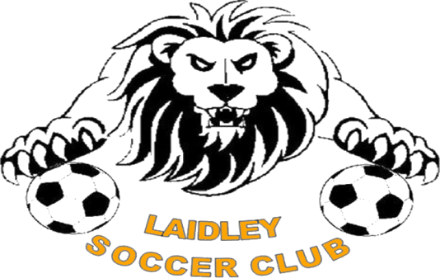
Good Sports Level 2 Website Copy

We are a Good Sports Level 2 accredited club.
Sporting clubs such as ours play a significant role in the community and have a responsibility to our members and their families. We have chosen to join over 6,500 clubs across Australia taking part in the Australian Drug Foundation’s Good Sports program. Through Good Sports we are committed to managing alcohol responsibly, ensuring smoke free areas and providing healthier food options, which we believe will help us to provide a healthy, safe and family friendly environment.

Through Good Sports we aim to:

- Eliminate risky drinking in the club through the promotion of a responsible approach to the sale and consumption of alcohol in the club
- Encourage healthy food choices before, during and after sport
- Protect juniors and other young people from the misuse of alcohol in and around the club
- Provide a responsible smoke-free club environment, through designated smoking areas
- Ensuring healthy meal, snack or drinks options are available and promoted
- Limiting the supply and promotion of less healthy food options

At Level 2, we are committed to:
- Not selling or consuming alcohol without an appropriate liquor license
- Training our bar staff in Responsible Service of Alcohol (RSA)
- Ensuring smoke free areas are available
- Organising safe and responsible social events
- Thinking ahead and ensuring players and members get home safely after functions
- Safe food handling practices
- Providing and promoting a range of healthy food choices
- Adjusting the content or variety of some foods for increased nutritional value

Speak to our club committee about what being a Good Sports club is all about or visit www.goodsports.com.au or www.Facebook.com/GoodSportsClubs

